Third-Person Project Game Design Document
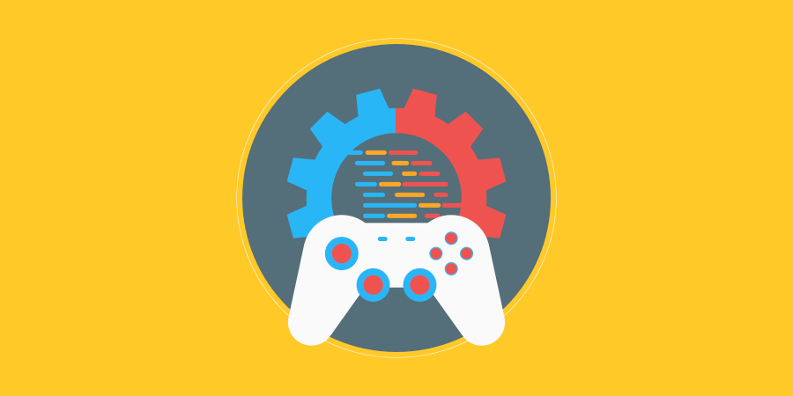

*Goblin Dungeon* working title
Alannah
Ethan
Hamish
Sophie
Tom

Contents
Overview 3
Elevator Pitch 3
Genre/s 3
Influences 3
Premise and Gameplay 4
Premise 4
Main gameplay mechanics 4
Hazards 4
Visual Assets 4
Asset list 4
Mood board 5

Overview

Elevator Pitch
<A one sentence pitch for your game>
Pretend that you are pitching your game to an executive in an elevator. You have less than 60 seconds.

Genre/s
- Platform
- Puzzle

Influences

Adventure Time
- Television show
- Art style, silly factor, cartoon visuals, general comedy beats

Crash Bandicoot
- Game
- Camera angle, art style inspo, platforming mechanicsm etc.
- Explain why this is an influence in one paragraph or less

Little big planet
- Game
- For the grabbing action

Premise and Gameplay

Premise
- The player will be a goblin who runs through a dungeon resetting traps for their master. At the end of the level, they must run back through the dungeon, dodging the traps.

Main gameplay mechanics (movement, other abilities etc.)
- Running, jumping
- general grabbing motion

Hazards
- <Hazard #1 (Static)> ****
- <Hazard #2 (Dynamic)>

Visual Assets

Asset list
- Dungeon assets from unity class, new goblin textures, new traps (models and textures), *****

Mood board
- <Include a minimum of 6 images as reference/inspiration for the aesthetic of your game>

